Bridgepoint Parts Catalog

Section VIII: Valves – Wand & Tools Page 1

PHY169-058 Valve – Hydramaster SS

Wand / RX-20

Repair Parts:
Stem Assembly: PHY012-002
O-ring Kit: 100012
Cap: PHY027-001
Spring: PHY155-003

PP61-950496

Valve – Prochem Wand

Repair Parts:
Rebuild Kit: PP66-808169
Stem: PP16-808189
Stem O-ring: PP43-810062
Stem Back-up Ring: PP43-810064
Seat: PP16-808228
Spring: PP16-808190
Stem Holder: PP16-808188

Rebuild kit contains Stem O-ring, Stem Back-up Ring, Seat, Stem, Spring, Stem Holder and O-ring.
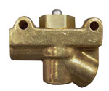
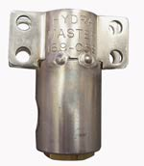

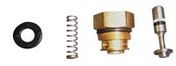

PHY169-014

Valve – Manual Ball

Dri-Master Upholstery Tool

Repair Kit: PHY078-371

PHY169-026

Valve – 1/8” Needle

Dri-Master Upholstery Tool

Round Plastic Knob: PHY061-065
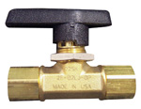

PP61-950570

Valve Assembly – Prochem

Truck mount Upholstery Tool

Valve Assembly Includes valve and:
Hose (PP10-805348)
VeeJet (B304)
Quick Connect (PKL01)

Repair Parts:
Rebuild Kit: PP66-808169
Stem: PP16-808189
Stem O-ring: PP43-810062
Stem Back-up Ring: PP43-810064
Seat: PP16-808228
Spring: PP16-808190
Stem Holder: PP16-808188
By-pass Stem: PP52-501626
O-ring BP Stem: PP43-810016
Rebuild kit contains Stem, Stem O-ring, Stem Back-up Ring, Seat, Spring, Stem Holder and O-ring.

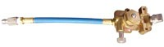

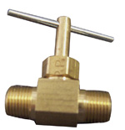

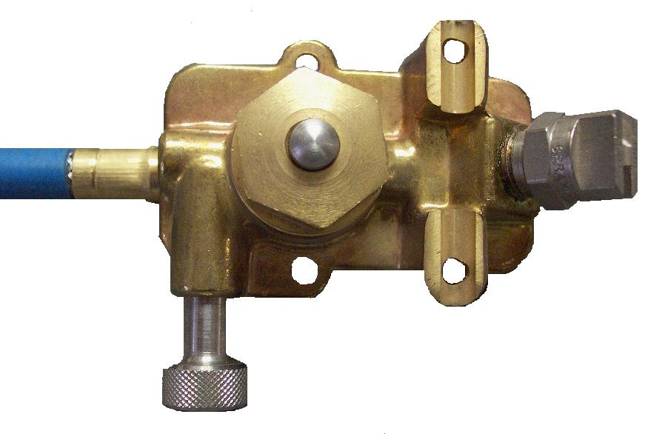

PKI254

Valve – Kingston HP

Repair Parts:
Stem Assembly: PKI25312TV
Cap: NA1233
Spring: NA1232
Stem O-ring: NA1230
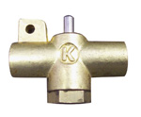

350PSI 225˚F

NA1229

Valve – Kingston LP

with lever

Repair Parts:
Stem Assembly: NA1231
Cap: NA1233
Spring: NA1232
Stem O-ring: NA1230

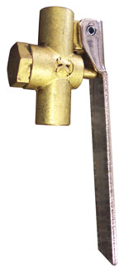

PKLSJ07

Valve 3” Truck Mount Upholstery Tool – with by-pass

Kleen Rite

Repair Parts:
Rebuild Kit: PKLSG03
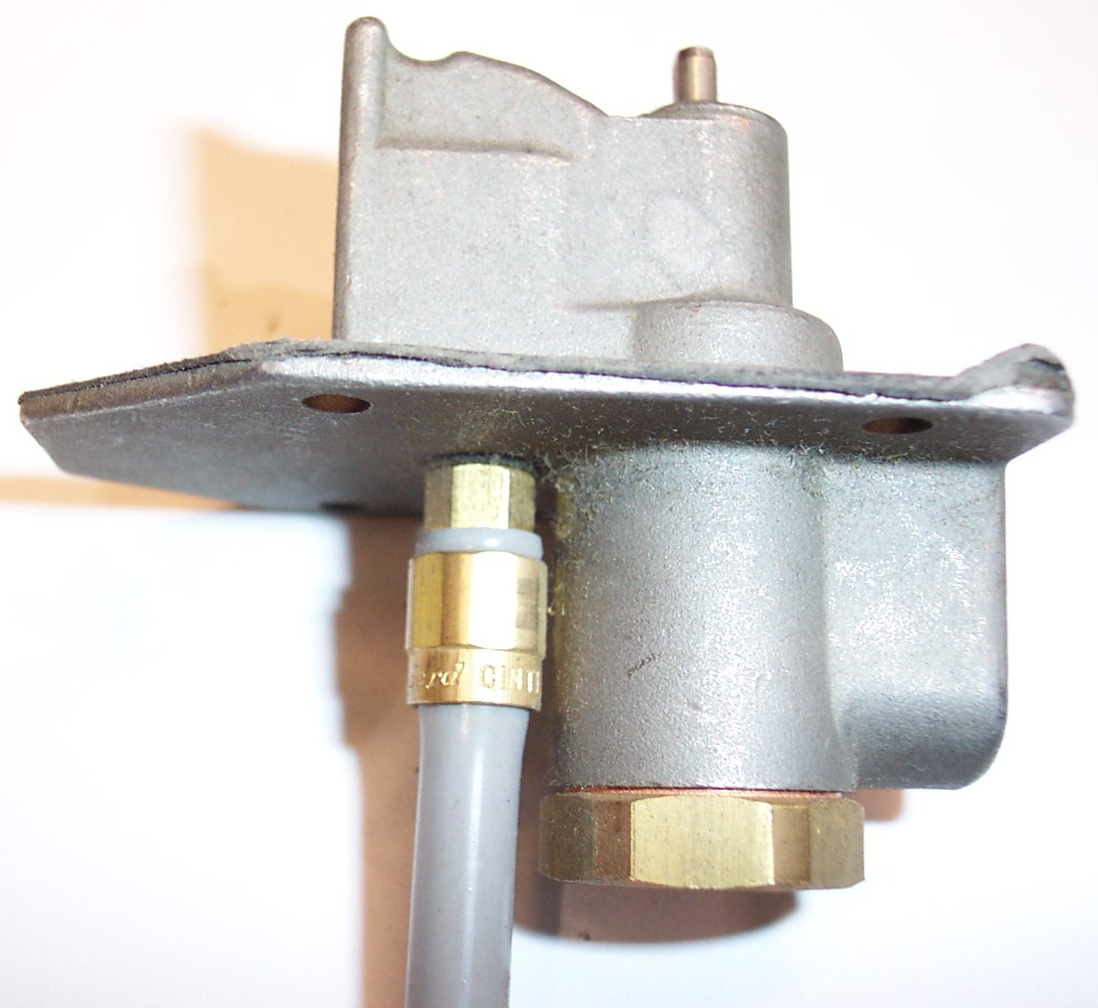

150PSI 200°F

100013

Valve – Kingston HP #251FT
Older AW29 wand valve
Repair Parts:
Stem Assembly: PKI251K
Cap: PKI251C

PKLSJ09

Valve 3” Standard Upholstery Tool – Kleen Rite

Repair Parts:
Rebuild Kit: PKLSG02
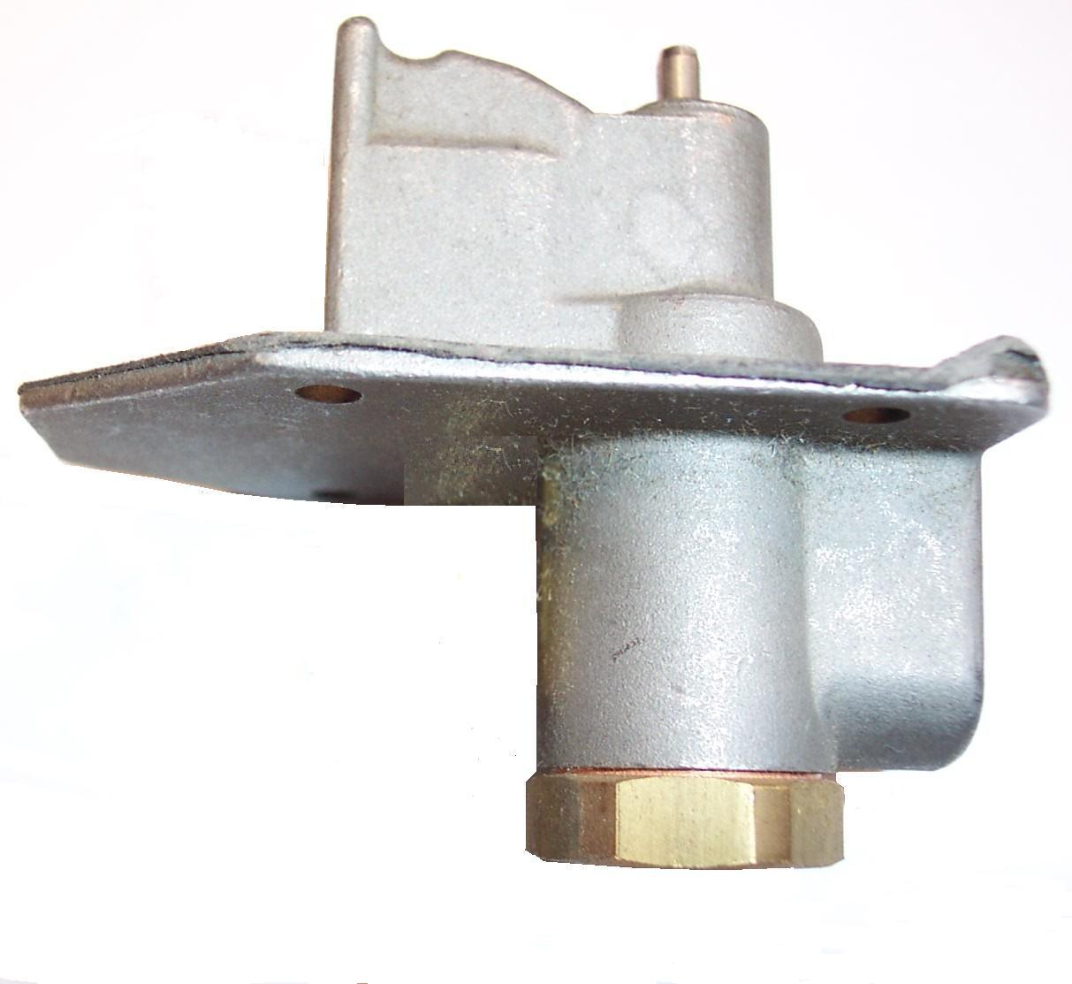

1000PSI 225˚F

Bridgepoint Parts Catalog

Section VIII: Valves – Wand & Tools Page 2

PMV120P

Valve – 120PSI with lever

Plastic
Repair Parts:
Rebuild Kit: PMV120PB

PMV120

Valve – 120PSI with lever

Aluminum

Rebuild Kit: PMV120B

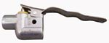
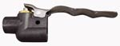

PMV300

Valve – 300PSI with lever

Brass

Rebuild Kit: PMV300B

PMV1245B

Valve – 500PSI Brass

with lever and hanger
Repair Parts:
Rebuild Kit: PMV124V5B

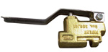
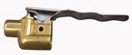

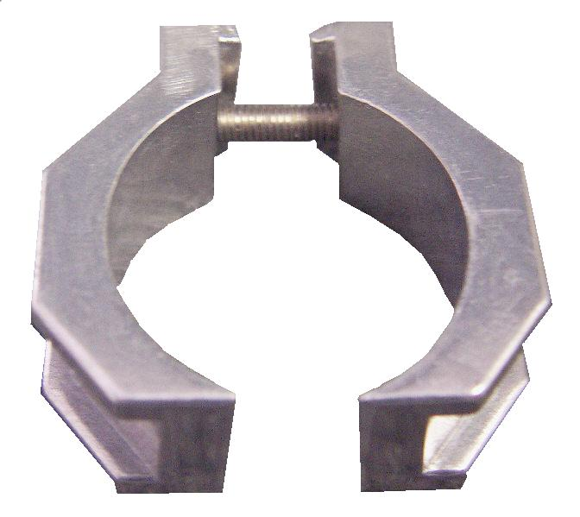

PMV1245P

Valve – 120PSI Plastic

with lever and hanger
Repair Parts:
Rebuild Kit: PMV124V5B

PMV800

Valve – 800PSI with lever

Brass
Repair Parts:
New EZ Rebuild Kit: PMV800SR
Old Rebuild Kit: PMV800B
Old Stem Assembly: PMV800S
Lever: PMV64

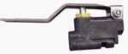
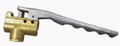

PMV4N

Valve – 500PSI with lever

Brass
Repair Parts:
Rebuild kit: PMV124V5B

NM4079 Valve & Handle

Hydrokinetic Tool

Repair Kit: PMV124V5B

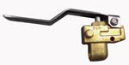

PMV2PS-EZ

Valve – 1000PSI

Stainless Steel

Rebuild Kit: PMVRV2P-EZ
Cap: NA1233

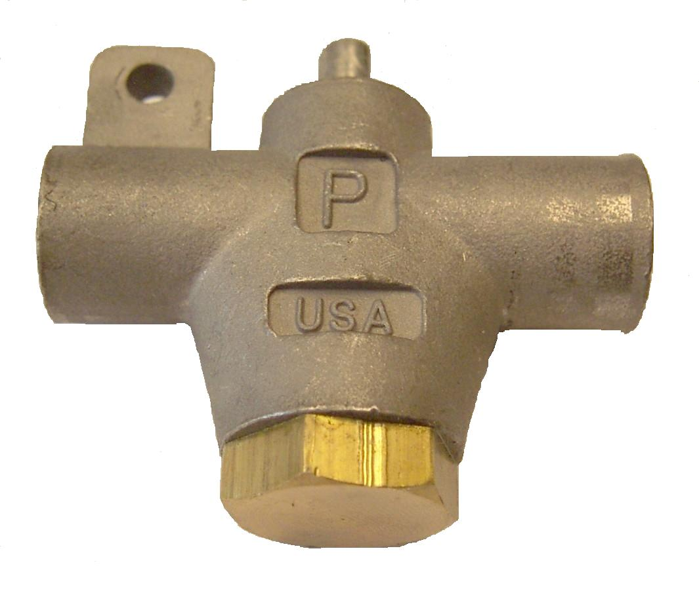

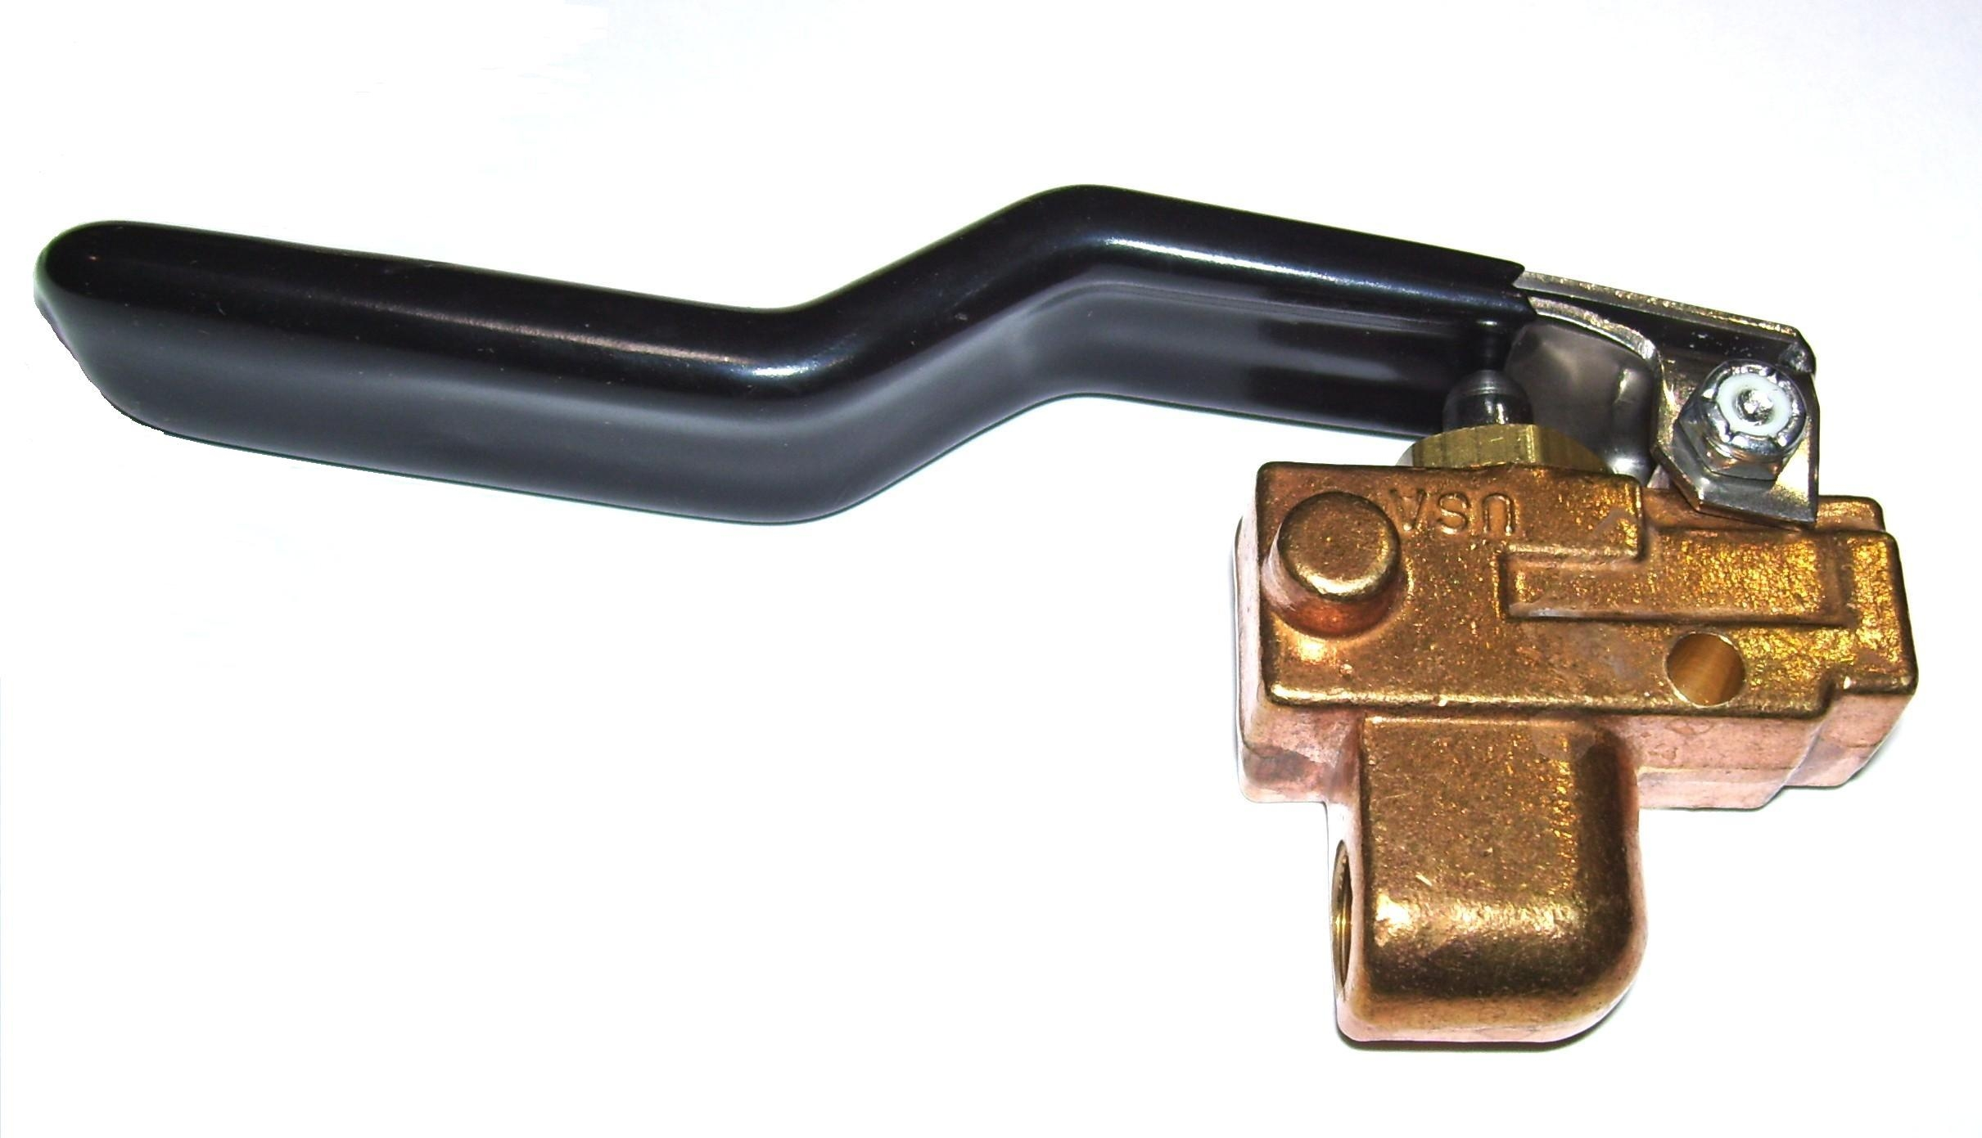

PMRV2P-EZ

Repair Kit for V2P-EZ Valves
Stainless Steel Ball & Stem

PMVRV2P

Rebuild Kit for Old P-Valves
Used for both the 500psi Brass valve & 1000psi Stainless Steel Valve

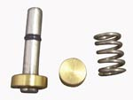

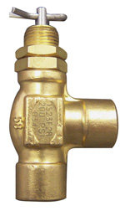

PP15-808018

Valve – Upholstery Tool

Hoke Valve
Prochem - Old Style

Repair Parts:
Stem Assembly: PP16-808132

PWM-B039-3

Valve – Paraplate
White Magic Wand
Repair Parts:
Stem Assembly: PWM-B039-1
Trigger: PWM-B042
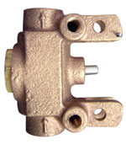

NM3043

Valve – Hand Tool

System III - Whitey Valve

Repair Parts:
Lever: NM3047
Lever Pin: NM3045
Stem Assembly: PSASS-3AS-16

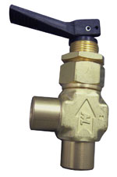

PHY169-054

Valve – Schrader
Repair Parts:
Rebuild Kit: PHY078-024
Seat: PHY174-035
Spring: PHY155-006

DISCONTINUED
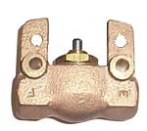

Bridgepoint Parts Catalog

Section VIII: Valves – Wand & Tools Page 3

NA0820

Valve – Metal Spray Gun with Viton Packing
5GPM - 1000PSI - 200°F

Used on AS08M, AS22A & AS89

Repair Parts:
Shut Off Disk: NA0822
Stem: PS7482-1-BR
V-Packing: PF1425S-1-VI
Repair Kit: (Stem & V-Packing) NA0821

NA0820A Valve – Plastic Spray Gun

5GPM - 1850PSI - 180°F
Used on AS08, AS08R, AS23, AS18, AS71, AS73XL & AS74 Sprayers. Also used on the AS58 & AS60 Pressure washing guns.
Repair Parts: Valve: NA0845
Rebuild Kit: NA0842

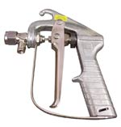
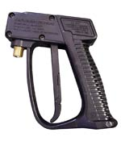

MV910

NA032

Valve – Plastic Spray Gun
7GPM - 2150PSI - 210°F
Used on SX-7 & Mini Turbo
Repair Parts: Valve: NA0847
Rebuild Kit: NA031A
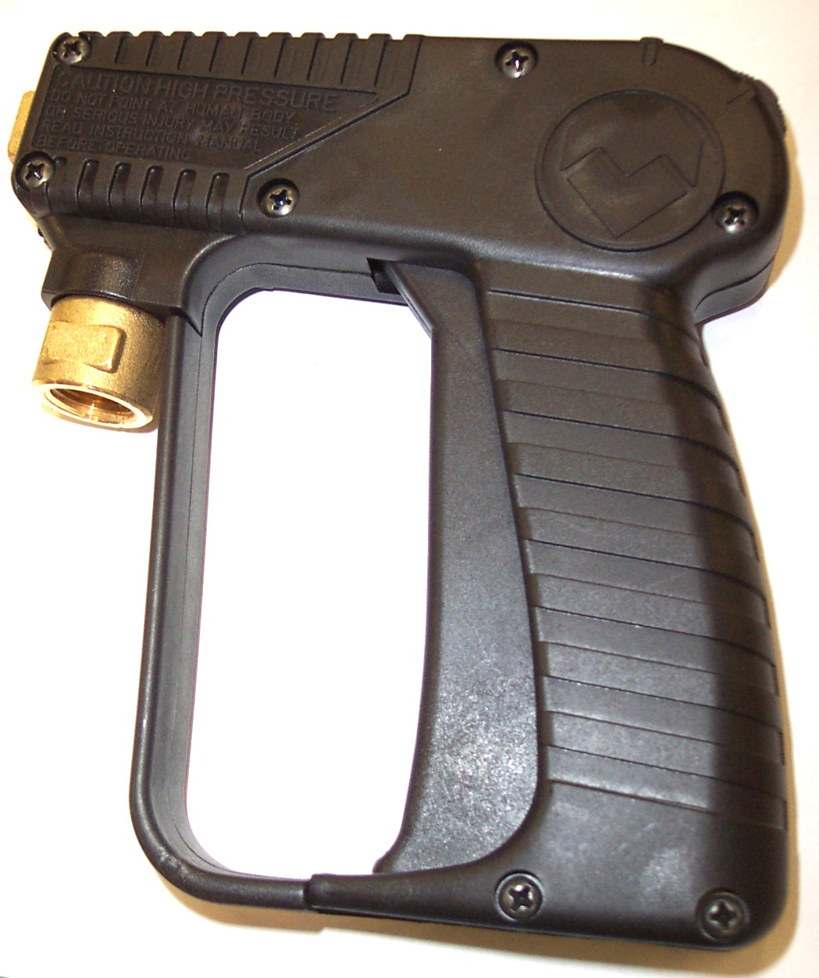

100010 (Old Style)

Valve – Plastic Spray Gun
7GPM - 2600PSI - 210°F

Used on SX-12 - AW104,
Gekko Tool s - AR54 & AR54A
Also new HydroForce AS08 & AS08R
Repair Parts:
Valve: NA031
Rebuild Kit: NA031A
Plastic Gun Body Only: NA031B
(Holes must be drilled through Plastic Gun body to mount Spray Gun on Gekko Tool or SX-12 handle.)

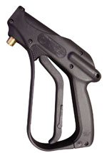

MV900

PT11

Valve – Plastic Spray Gun

Turbo Tool AW42
4000psi 10gpm Cat #31096
Rebuild Kit: PT11A
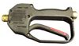

DISCONTINUED
MV960

100010 (New Style)

Valve – Plastic Spray Gun
7GPM - 2750PSI - 210°F

Used on SX-15, SX-12, Gekko Tools,
Hydro Force AS08, AS08P & AS08R
Repair Parts:
Valve: NA033
Rebuild Kit: NA033A
Plastic Gun Body Only: NA031B

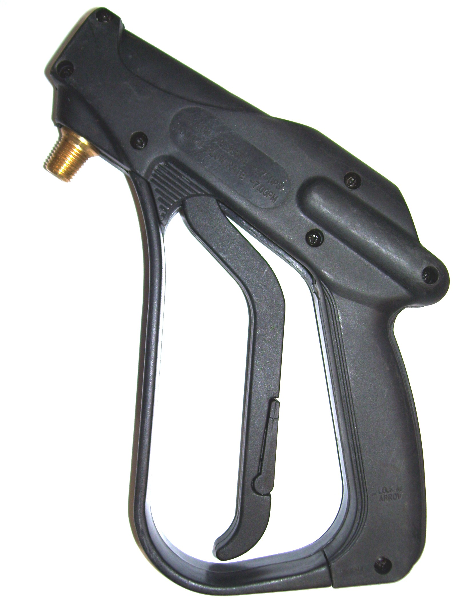

AW795

VALVE SOFT-TOUCH

UPHOLSTERY TOOL
Rebuild Kit: AW796

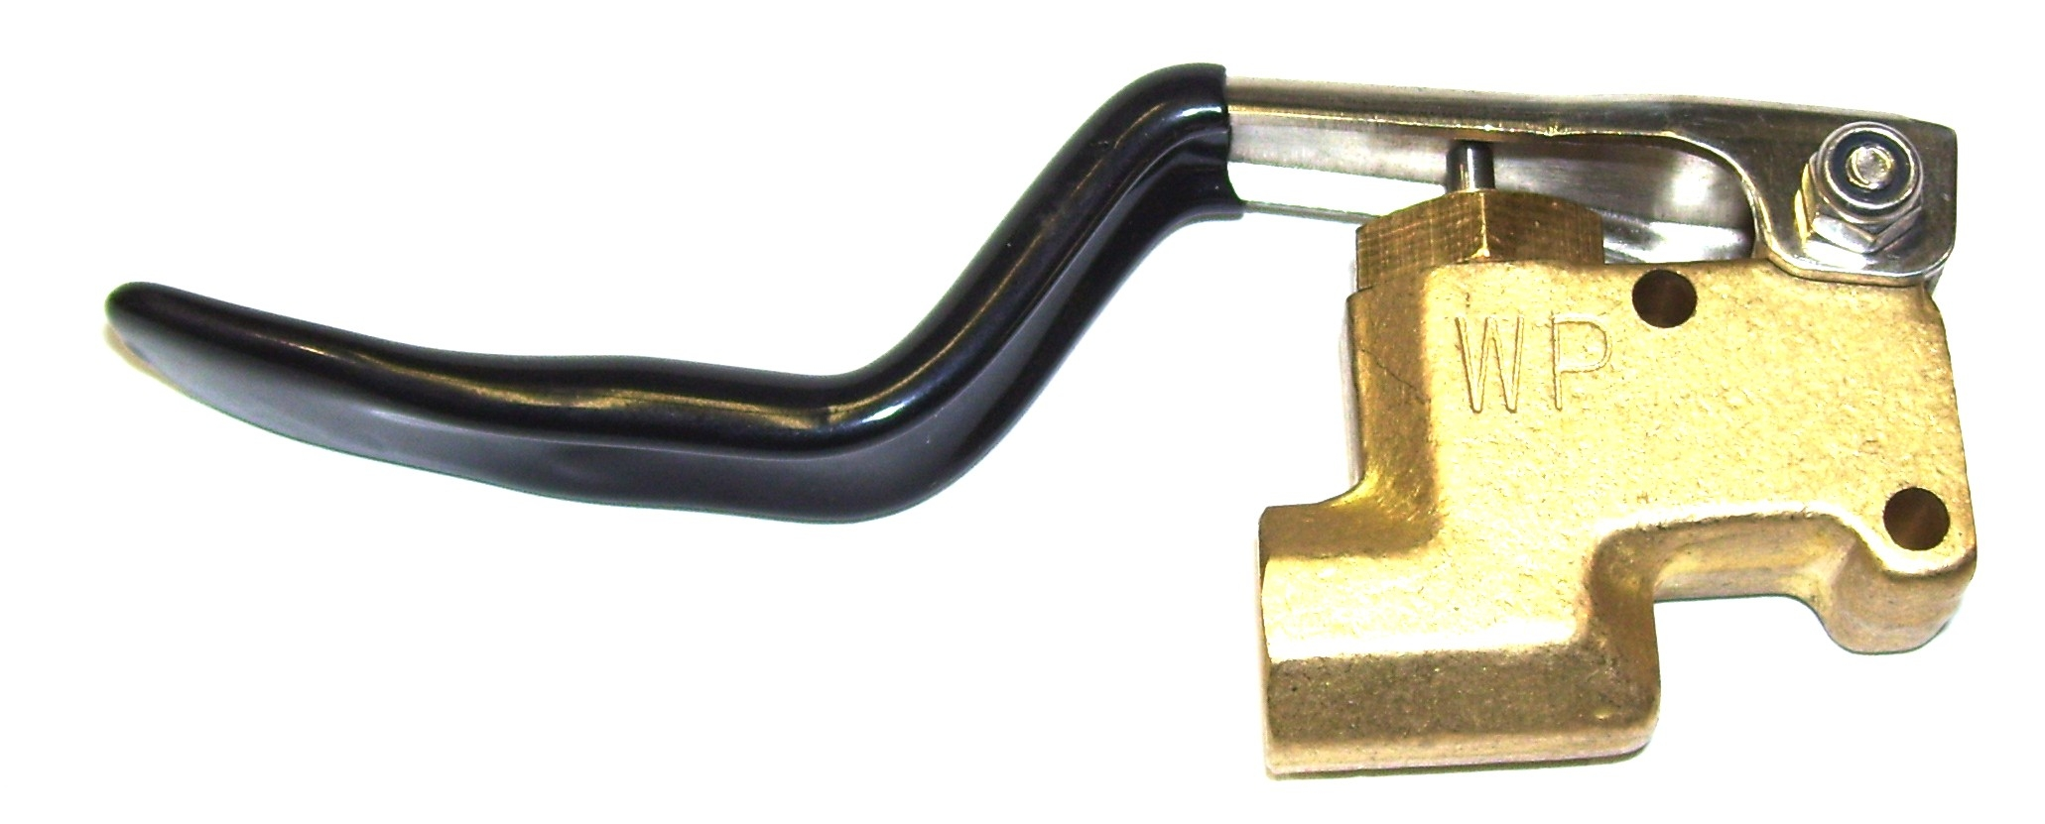

AW791

VALVE SOFT-TOUCH

BRASS 1200PSI
Repair Parts:
Rebuild Kit: AW794

AW792

VALVE SOFT-TOUCH

STAINLESS STEEL 1500PSI
Repair Parts:
Rebuild Kit: AW794

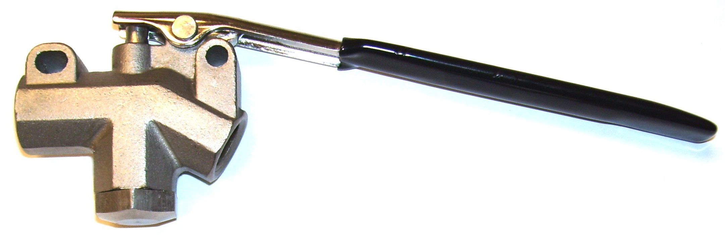
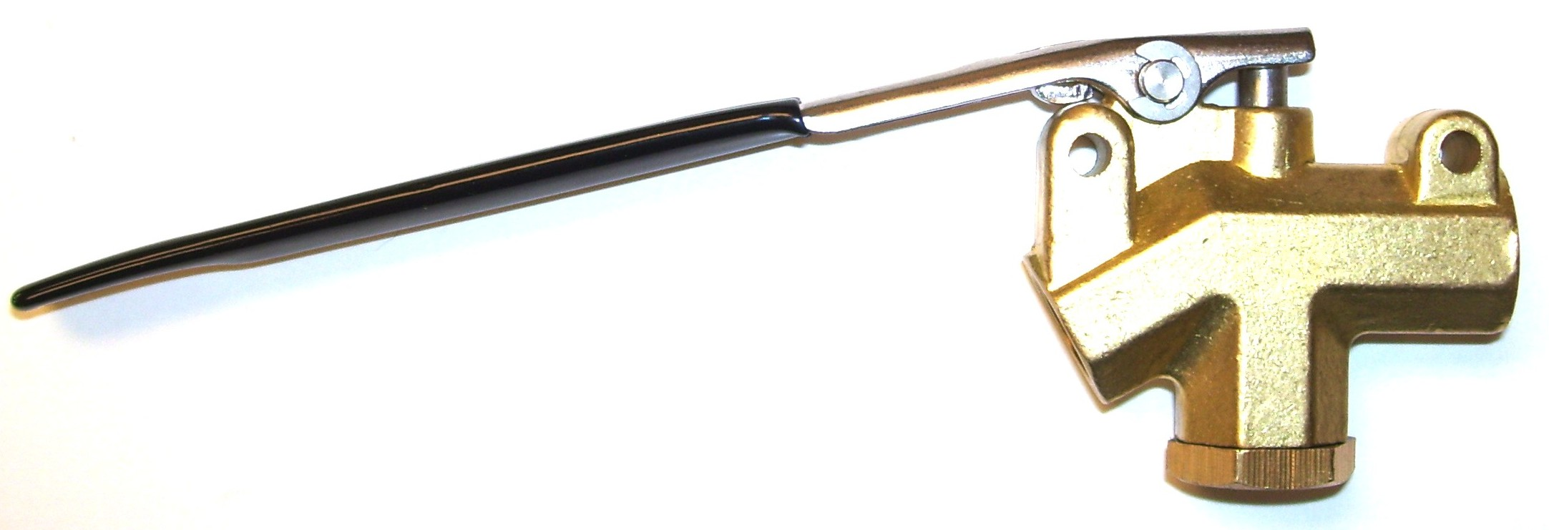

PCMPV1175

Valve – Kingston HP- #251-30

Brass with Trigger
Newer AW29 Wand Valve
K-Valve Repair Kit: PK25130

AW793

PROCHEM WAND ADAPTER KIT

For AW791 & AW792

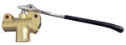
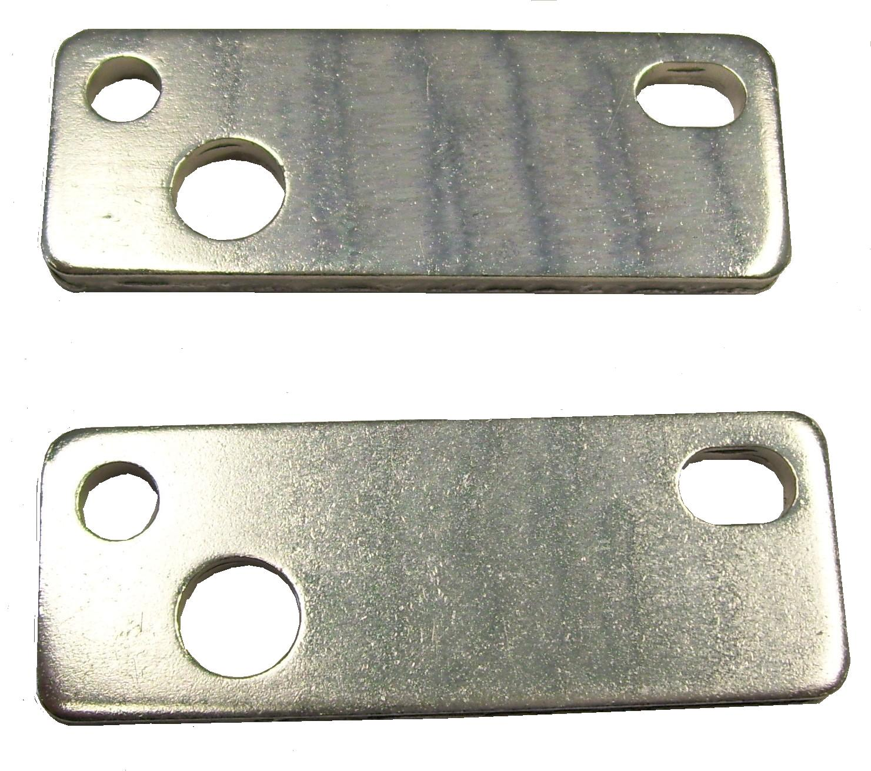

1200PSI 225˚F

PS6590

Trigger Valve
Repair Parts:
Rebuild Kit: PS6590KIT

NS156

Valve – Plastic Shut Off

AS73 Sprayer

NA1409

Valve – Plastic Shut Off

AS14 Sprayer
Repair Parts: Lever: NA1409A
PST010 DISCONTINUED

Valve – Steam Genie Wand
Rebuild kit: PST002
Pin-Handle: PST003
Plunger: PST005
Cylinder: PST006
Spring: PST007
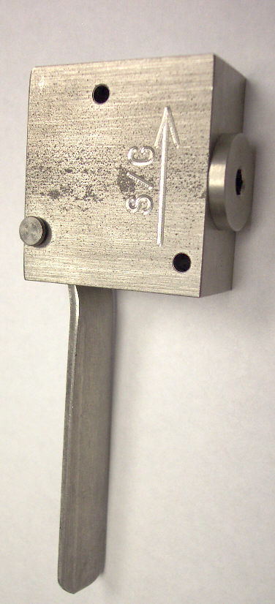
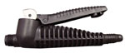
NO LONGER AVAILABLE

NA1566

Valve – Zinc Shut Off

AS21 Sprayer

NA1608

Valve – Brass Shut Off

AS16 Sprayer

AS202 Sprayer

AS204 Sprayer

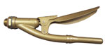
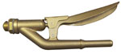
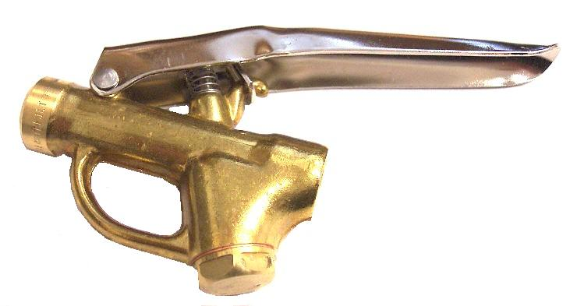
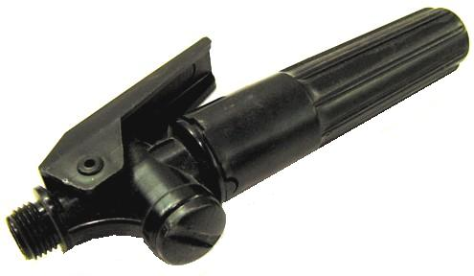
Bridgepoint Parts Catalog

Section VIII: Valves – Wand & Tools Page 4

PS43000083

Valve – Plastic Shut Off

AS14A Sprayer

PS42037500

Valve – Brass Shut Off

AS16A Sprayer

